What are Runnables in LangChain
https://www.youtube.com/watch?v=u3b-W1NgYa4&list=PLKnIA16_RmvaTbihpo4MtzVm4XOQa0ER0&index=10
https://colab.research.google.com/drive/1gv3e-OfHCi6IuVBVR7xWmrcVl6gHsydv?usp=sharing
https://colab.research.google.com/drive/1P11hpAPtjr0oIiqQ5pNsdnMxmascdbBY?usp=sharing
00:00 – Intro
01:39 – Recap
03:12 - Why do runnables exist?
11:45 - Simple LLM App
24:00 - Different Types of Chains
26:44 – Problems
33:44 - What are runnables?
39:47 - Code Demo
LangChain Runnables Video Documentation
2. Recap of Previous Video
- Previous video focused on Chains in LangChain.
- Chains are an important component of LangChain that orchestrates multiple steps.
- Types of Chains learned previously:
  - Sequential Chain – Executes steps one after the other.
  - Parallel Chain – Executes multiple chains concurrently.
  - Conditional Chain – Executes chains based on conditions.
- Key Point: Chains work because of Runnables; understanding Runnables is necessary to fully utilize Chains.
- Learning Objective for this Video:
  - Define Runnables
  - Explain their importance
  - Demonstrate different types of Runnables in LangChain

3. Why Do Runnables Exist?
3.1 Historical Context
- 2022 – ChatGPT Release: November 2022
- OpenAI released public APIs allowing developers to build their own LLM-based applications.
- LangChain team observed:
  - Future demand for LLM-based applications will increase.
  - LLMs can understand text and generate relevant responses.
- The team realized the need for a framework that simplifies building LLM-based applications.

3.2 Problem: Multiple LLM APIs
- Many companies (OpenAI, Anthropic, Google, Mistral, etc.) provide LLM APIs.
- Each API behaves differently.
- Developers need a unified framework to interact with any LLM with minimal code changes.
Solution:
- LangChain provides abstraction classes for multiple LLM APIs.
- Developers can switch LLM APIs easily without rewriting code.

3.3 Problem: LLM Interaction is Only One Component
- Interacting with an LLM is only a small part of building applications.
- Example: PDF Reader Application Workflow
  - Load PDF from cloud or local storage.
  - Split PDF into chunks (chapters, pages, paragraphs).
  - Generate embeddings for each chunk.
  - Store embeddings in a vector database.
  - Retrieve relevant chunks using semantic search.
  - Send chunks to the LLM and return the response to the user.
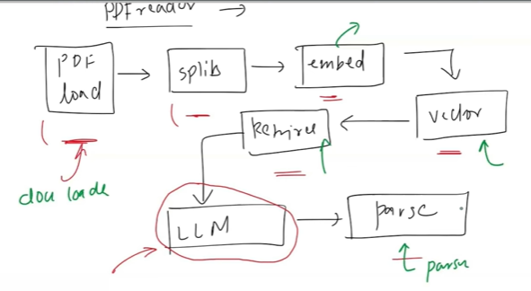
- Observation: LLM interaction is just one task; many other components are required.

3.4 Problem: Multiple Supporting Components
To build LLM-based applications, developers need to handle:
- Document Loaders – For loading files.
- Text Splitters – For breaking text into chunks.
- Embedding Models – For generating vector representations.
- Vector Stores & Retrievers – For semantic search.
- Output Parsers – For formatting results.
- Memory Components – For context storage.
- Managing all these manually increases complexity.
- Need for modular components that simplify development.

3.5 LangChain Solution
- LangChain created modular components
  - Document Loaders, Text Splitters, Embeddings, Retrievers, Parsers, Memory components.
- These components can be combined and reused to build any type of LLM application efficiently.

3.6 Code Demonstration
- Simple LLM Application:
  - Takes a topic input from the user.
  - Generates a prompt and sends it to the LLM.
  - Displays LLM response to the user.
- Complex Application (PDF Reader):
  - Shows full workflow using LangChain components.
  - Demonstrates how modular components simplify code for complex applications.
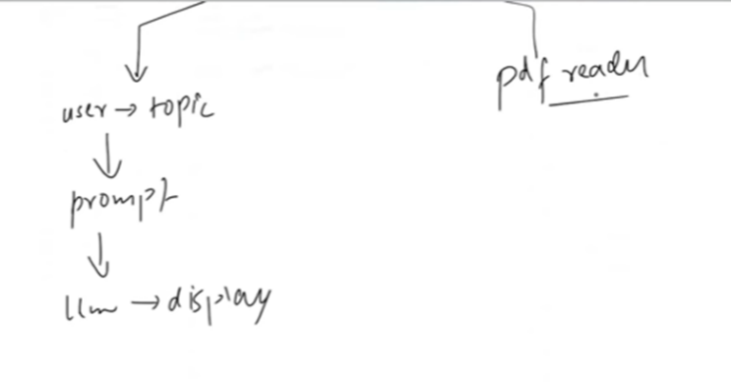
Key Insight:
- Using LangChain components reduces manual effort, allowing developers to focus on application logic rather than low-level integration.

- Simple LLM Application
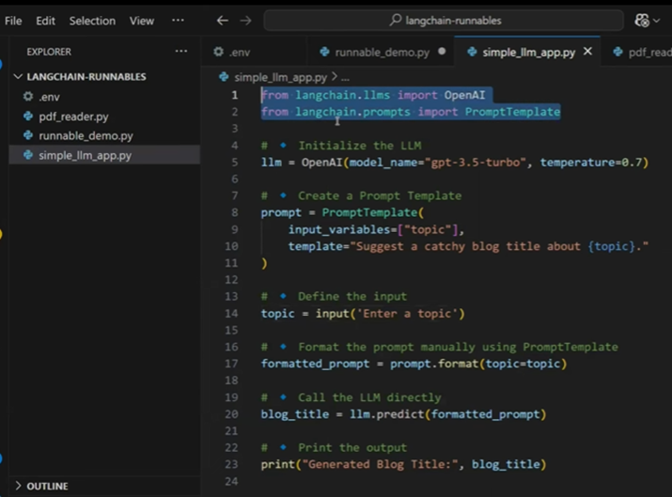
- Purpose: Demonstrate how LangChain components simplify building a simple LLM-based application.
- Components Used:
  - LLM Component – To create an LLM instance.
  - PromptTemplate Component – To format prompts.
- Workflow:
  - Ask user for a topic input.
  - Format the topic into a prompt using PromptTemplate.
  - Send the formatted prompt to the LLM component.
  - Get LLM prediction/response.
  - Display the response to the user.
- Key Insight: With just these two components, a fully functional LLM application can be built quickly.

- PDF Reader Application
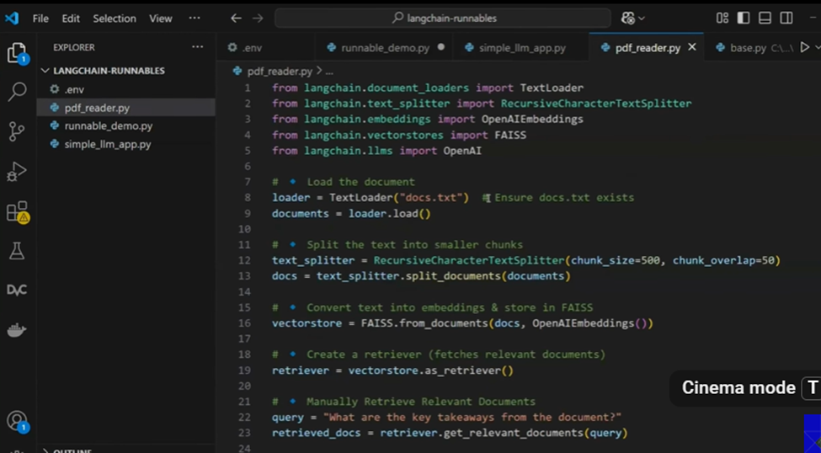
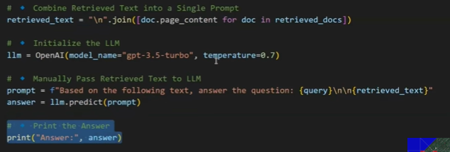
- Purpose: Demonstrate a more complex LLM application using multiple LangChain components.
- Components Used:
  - Document Loader – Loads documents (e.g., PDF or text files).
  - Recursive Character Text Splitter – Splits documents into smaller chunks.
  - Vector Store – Stores embeddings for each chunk.
  - Retriever – Performs semantic search on vector database.
  - LLM Component – Generates final response.
- Workflow:
  - Load document (PDF or text).
  - Split document into chunks using Text Splitter.
  - Generate embeddings for each chunk using Vector Store.
  - Store embeddings in vector database.
  - When a user query arrives, use Retriever to find relevant chunks.
  - Combine retrieved text with query to create a new prompt.
  - Send the prompt to the LLM component.
  - Display the LLM response.
- Observation:
  - Previously, this process required manual coding of 36 lines of code.
  - With LangChain components, the same task can now be done efficiently with 32 lines of code.
- Eureka Moment:
  - LangChain team noticed that most LLM tasks share common repetitive steps, e.g., creating prompts and sending to LLM.
  - Solution: Introduce automation via Chains, allowing multiple components to be connected and run-in sequence.
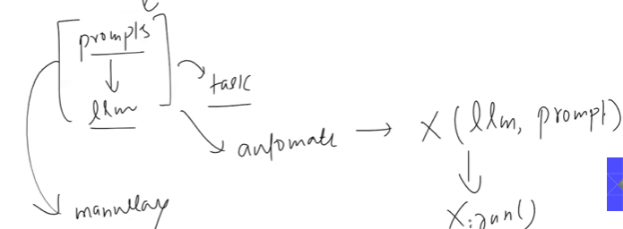

6. Introduction to Chains
- Definition: Chains are built-in functions that automate connecting two or more LangChain components.
- Types of Chains:
6.1 LLM Chain
- Simplest chain.
- Takes an LLM instance and a PromptTemplate, automatically generates the prompt and sends it to LLM.
- Reduces manual work like calling format() or predict() functions.
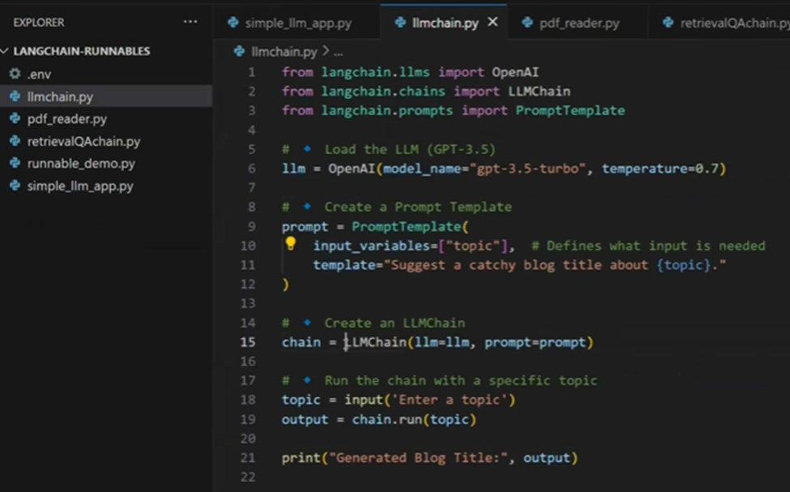
6.2 Retriever QA Chain
- Automates tasks like RAG (Retrieval-Augmented Generation).
- Workflow:
  - Accept an LLM and a retriever as input.
  - Automatically retrieve relevant text from vector database.
  - Generate a prompt combining query and retrieved text.
  - Send prompt to LLM and get answer.
- Simplifies complex tasks like PDF Reader queries.
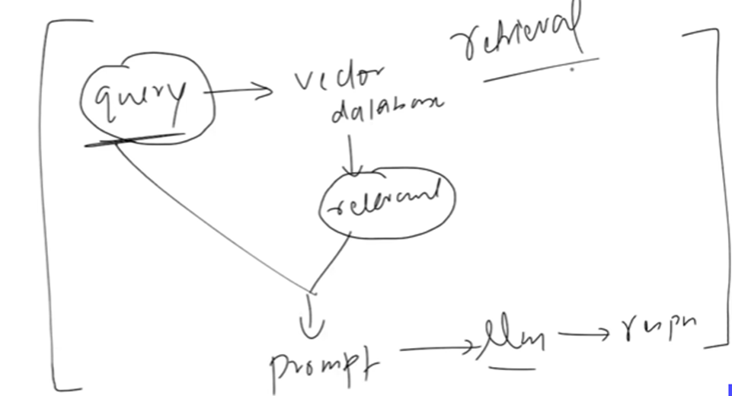
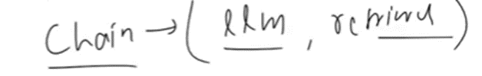
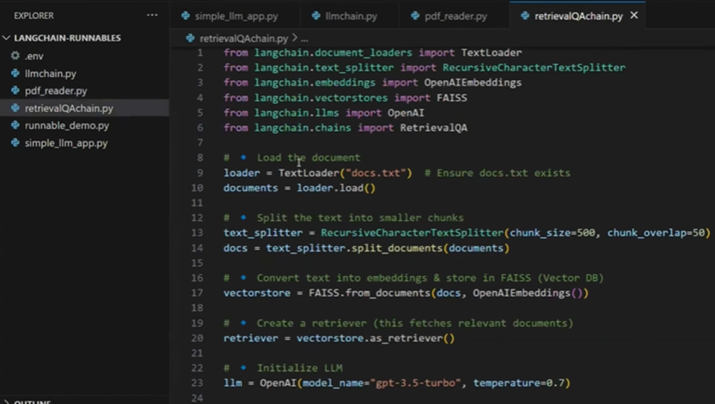
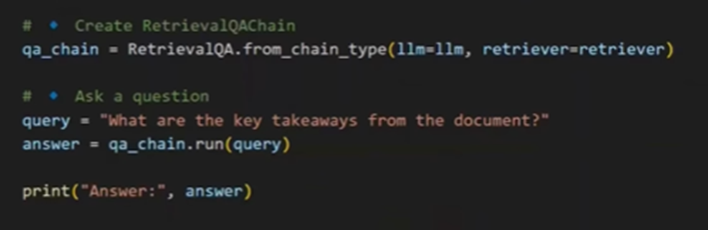
6.3 Other Chain Types
- Simple Sequential Chain – Combine multiple LLM chains sequentially.
  - Example: Generate a joke, then generate an explanation for the joke.
- Sequential Chain – Supports multiple inputs and outputs.
- API Chain – For interacting with APIs.
- LLM Math Chain – For math-based problems.
- Other reusable chains – Developed for tasks frequently repeated across applications.
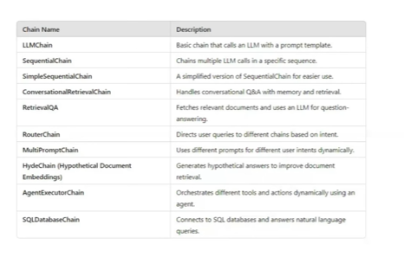
Key Insight:
- Chains allow AI engineers to reuse components efficiently.
- Chains provide higher abstraction, reducing manual coding effort for complex workflows.
6.4 Limitation Identified
- As more chains were developed, the LangChain team realized that managing many chains could become complex, requiring careful structuring and reuse.

7. Problems with Too Many Chains
- Observation:
  - LangChain created many chain functions to solve different use cases.
  - This led to two major disadvantages:
    - Large codebase: Maintaining a huge codebase became challenging.
    - Steep learning curve: New AI engineers found it difficult to know which chain to use for which use case.
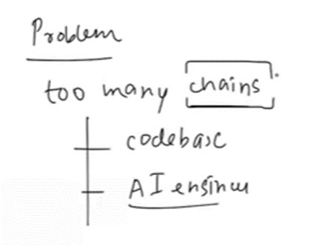
- Intended Goal of Chains:
  - LangChain components (LLM, Prompt, Retriever, Parsers) were designed to be like Lego blocks.
  - Goal: AI engineers should seamlessly plug components together to create flexible workflows.
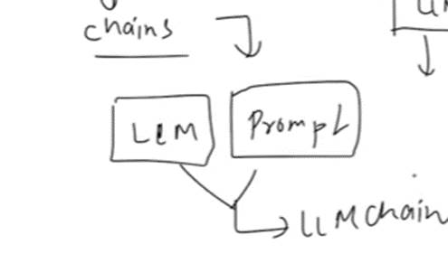
- Why Problems Occurred:
  - Components were not standardized:
    - Each component had a different interface.
    - Example:
      - LLM → predict()
      - PromptTemplate → format()
      - Retriever → get_relevant_documents()
      - Parser → parse()
  - Because interfaces were incompatible, custom code had to be written for every new use case.
  - Result: Heavy codebase and difficulty in learning LangChain for newcomers.
- Realization by LangChain Team:
  - Standardizing components would have allowed seamless connection without custom functions.
  - Next step: Rebuild components in a standardized way, making them connectable and reusable.
  - Solution: Runnables (to be discussed next).
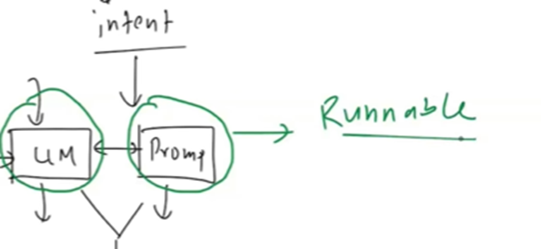

8. What Are Runnables?
- Definition:
  - A Runnable is a unit of work.
  - It takes input, processes it, and returns output.
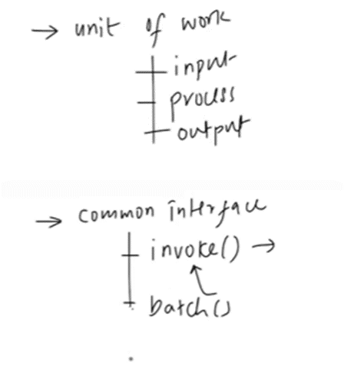
- Key Characteristics:
  - Single Purpose: Each Runnable performs one task.
  - Common Interface:
    - All Runnables in LangChain follow a common interface.
    - Popular methods:
      - invoke(input) → Processes one input, returns output.
      - batch(inputs) → Processes multiple inputs at once.
      - stream(input) → Returns streaming output.
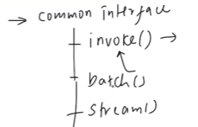
  - Connectable:
    - Runnables can be chained together.
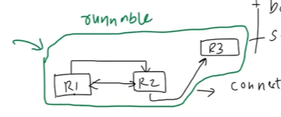
    - Example:
      - R1 → R2 → R3
      - Output of R1 becomes input for R2 automatically, and so on.
  - Composable Workflows:
    - Multiple Runnables can form a workflow, which itself is a Runnable.
    - Nested workflows can also be connected to build complex workflows.
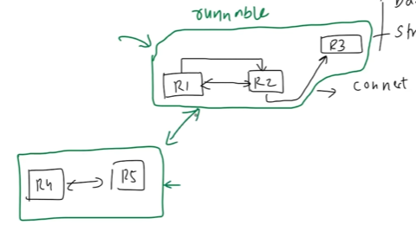
- Analogy: Lego Blocks
  - Single Purpose: Each Lego block has a specific function.
  - Common Interface: Connection points on blocks allow seamless attachment.
  - Connectable: Combine blocks to form larger structures.
  - Composable: Resulting structure can be combined with other structures.
- Significance:
  - Runnables solve the problems of too many chains and incompatible components.
  - They standardize interfaces, allowing easy connection and automation.
For one chain we are giving input and it is giving joke as an output – This output becomes input to another chain which generates explanation of the joke (So here the output of the one chain becomes input for another chain) – Its possible using runnables
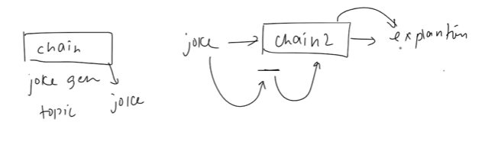

- Next Step (Preview):
  - After understanding Runnables conceptually, the next step is to see them implemented in code from scratch.
  - This will give a practical feel of how Runnables work, their input/output handling, and how they can be connected.

This section explains why chains became a problem and introduces Runnables as the solution for standardization, composability, and simplified workflow creation.

Code Demo (LLM and Prompt Template in Python)
Starting the Demo
I’m going to show you all the scenarios I explained earlier, but through code. We'll start from scratch. First, I’ll create two classes: one for an LLM (Large Language Model) and another for a prompt template. Using these two classes, we’ll try to build a small LLM application. I’ll code and explain as I go so you automatically understand what’s happening.

Step 1: Creating a Dummy LLM Component
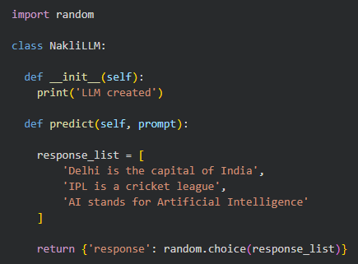
I want to create an LLM component in LangChain that AI engineers can use to interact with any LLM in the future. This LLM component won’t be real—it will be a dummy for demonstration purposes.
LLM Class Structure:
- Constructor: Prints "LLM Created" when called.
- predict method: Takes a prompt and returns a response.
Since we are not using a real LLM, I create a list of dummy responses:
responses = [
"Delhi is the capital of India",
"IPL is a cricket league",
"AI stands for Artificial Intelligence"
]
Each time predict is called; it randomly returns one of these responses using the random module.
Example:
llm = DummyLLM()
llm.predict("What is the capital of India?")
# Could return any of the three dummy responses

Step 2: Creating a Dummy Prompt Template
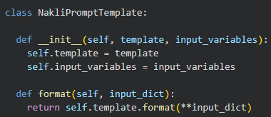
Next, I create a prompt template class.
Prompt Template Class Structure:
- Constructor: Takes template and input_variables.
- format method: Accepts a dictionary and returns the formatted prompt by unpacking the input dictionary.
Example:
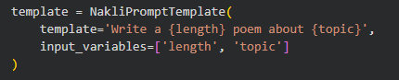
Step 3: Building a Simple LLM Application
Now that we have a dummy LLM and a prompt template, we can create a small application:
- Ask the user for a topic.
- The prompt template formats it.
- The LLM generates a dummy poem (response).
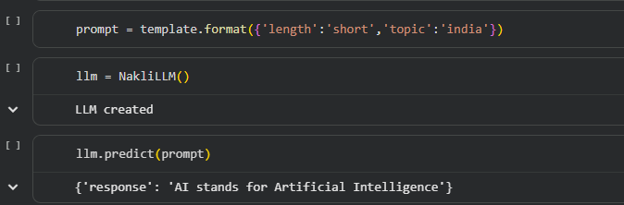

Step 4: Creating a Dummy LLM Chain
Manually combining the prompt template and LLM every time is tedious. To simplify, we create a DummyLLMChain class:
- Constructor: Accepts prompt and llm.
- run method:
  - Formats the prompt using the prompt template.
  - Sends the formatted prompt to LLM’s predict method.
  - Returns the LLM’s response.
This allows AI engineers to just call chain.run() without worrying about the details of formatting or prediction.
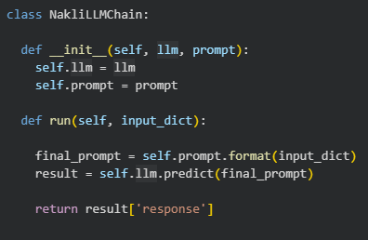
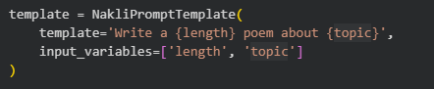
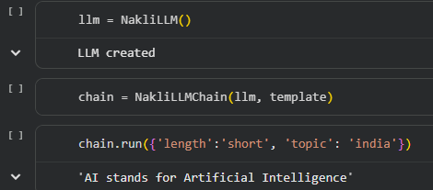

Step 5: Problem with Flexibility
This basic chain works fine for a single step. But if you want a multi-step workflow, like:
- Generate a joke.
- Generate an explanation of that joke.
The basic chain is not flexible—you can’t easily call the LLM multiple times in a row.
Solution: Standardize all components using Runnable Interface.

Step 6: Standardizing Components with an Abstract Class
We create an abstract class Runnable:
- Ensures all components have a common invoke method.
- Components like LLM or PromptTemplate inherit from Runnable.
- Forces implementation of invoke in child classes.
Example:
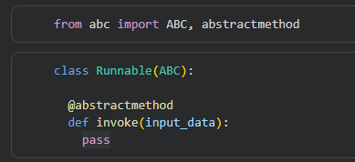
Updating Dummy LLM and PromptTemplate:
- predict method’s functionality is now moved into invoke.
- Old predict or format can print a warning that it’s deprecated.
Dummy LLM inherits from Runnable and overrides the invoke() method. It does not remove the predict() function because many users are still using it. For those who call predict(), a warning will be shown stating that this method is deprecated and will be going to be removed in the future.
All components are Runnables that inherit from the same abstract class, and every component has the same invoke() method to produce the result. Because of this common interface, the components can be easily connected to each other, which allows us to combine multiple chains seamlessly.
In the below example we can see that every component has invoke method which is the standardized format
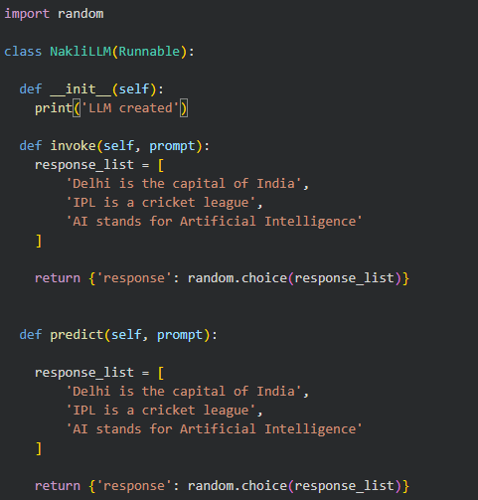
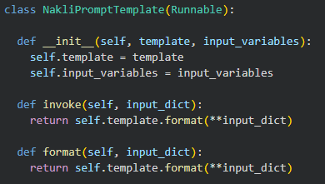
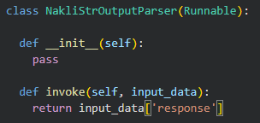

Step 7: Connecting Components into Chains
We can now build a RunnableConnector class:
- Constructor accepts a list of Runnable components.
- invoke loops over the list:
  - Calls invoke on the first component with input.
  - Passes its output as input to the next component.
  - Returns the final output.
This allows us to chain any number of components (LLM, PromptTemplate, Parsers, etc.) dynamically.
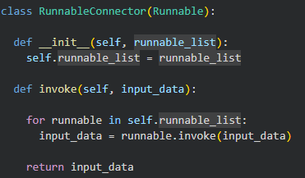
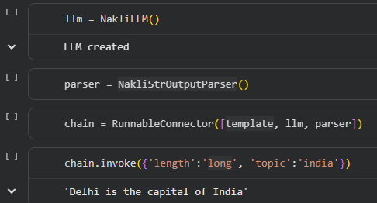

Step 8: Multi-Step Chains
Example:
- Chain 1: Generate a joke from a topic.
- Chain 2: Generate an explanation for the joke.
We can then connect Chain 1 and Chain 2 into a final chain using RunnableConnector and call invoke once.
- Output will be the final explanation of the joke.
- You can add more components to extend the workflow.
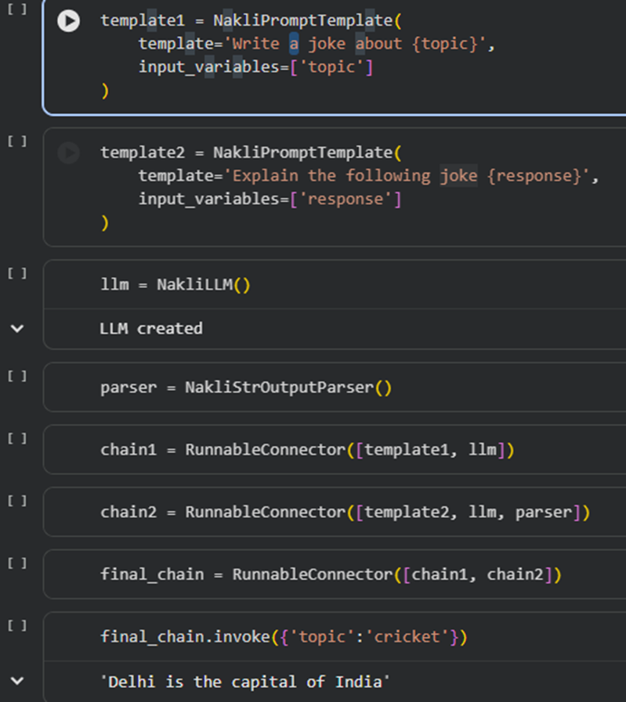

Step 9: Benefits
- Standardized interface (invoke) for all components.
- Components are reusable and flexible.
- Multiple chains can be connected like Lego blocks.
- You can build very long, multi-step workflows without writing custom functions each time.

Conclusion
- First, we built dummy LLM and prompt template components.
- Then, we standardized them using the Runnable abstract interface.
- Finally, we connected components into flexible chains using RunnableConnector.
- This demonstrates the core idea behind how LangChain allows building complex LLM workflows with reusable, chainable components.

